AMDP Script

_
errortab и поле sql__procedure__source__record

С 7.5 стало обязательно заполнять errortab и поле sql__procedure__source__record

errortab = select * from :errortab where 1 = 0;
row_number( ) over() as sql__procedure__source__record

_
Условие в SELECT

SELECT CASE (level = 8) THEN … CASE (level = 7) THEN …

_
Пробелы в SELECT

-- 'ABC'
SELECT 'A' || ' ' || 'B' || ' ' || 'C' FROM <any table>;

-- 'A B C'
SELECT 'A' || CHAR(32) || 'B' || CHAR(32) || 'C' FROM <any table>;

_
Техн. поля SQL_PROCEDURE_SOURCE_RECORD и RECORD

After processing the field routines and the other rules it is necessary to bring the results together. To do so one must bring all three data packages in the same order. Each data package contains two technical columns for this purpose. The Calculation Scenario contains an order projection for each processing thread to align the data of each thread in the same order.
Therefore, do not change or delete the values from the two technical columns SQL_PROCEDURE_SOURCE_RECORD and RECORD.
Changing the sorting order of the data column causes errors when merging the individual packages.
This kind of error is very difficult to identify. The result does not lead into a technical error. Only the values from one or more columns are in wrong rows.

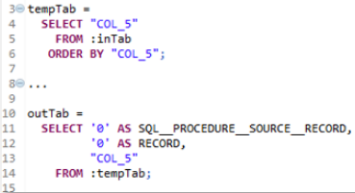 | 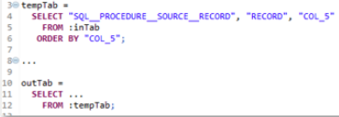
Плохой стиль | Так лучше

_
Параллельная обработка полей

Если несколько полей переносятся один к одному

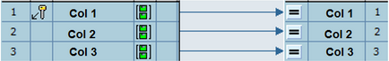,
а некоторое поле с использованием формулы

outTab =
select “Col 5”, “RECORD”, “SQL_PROCEDURE_SOURCE_RECORD”
from :inTab
where “Col 5” >= ‘01/01/2017’;

то, чтобы не было значений NULL

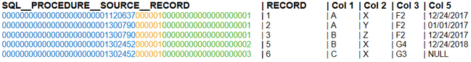

лучше использовать следующий вариант формулы

outTab =
select case
when “Col 5” >= ‘01/01/2017’ then “Col 5” else ‘0000000000’ end as “Col 5”,
“RECORD”, “SQL_PROCEDURE_SOURCE_RECORD”
from :inTab;

_
Formula having CONCATENATE function doesn’t not work, if you use it in expression ‘IF’
Example
IF( SUBSTRING( FISCPER, 0, 4 ) = '3000', CONCATENATE( '1999', SUBSTRING( FISCPER, 4, 3 ) ), FISCPER )

Solution
Change the syntax as per below

IF( SUBSTRING( FISCPER, 0, 4 ) = '3000', '1999' & SUBSTRING( FISCPER, 4, 3 ), FISCPER )

_
Вместо
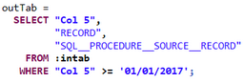
лучше использовать
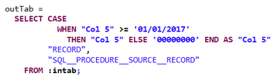

_
Within the BW all fields are defined as NOT NULL columns. The SQL function COALESCE (ˌkəuəˈles соединять, объединять) could be used to avoid NULL values and ensure that all values would be initialed correct in case of NULL values.

COALESCE( inTab."MATERIAL”, '' ) AS "MATERIAL”
COALESCE( inTab."KEYFIGURE”, 0 ) AS "KEYFIGURE”.

_
The calculation engine tries to optimizer the SQLScript coding in order to compile all local select statements to one select statement. Therefore the single statements would be in-lined

tab2 = select C from (select A,B,C from T where A = 1) where C=0;

_
A further option to prevent inlining is to put the coding into a SEQUENTIAL EXECUTION block. All statements inside a SEQUENTIAL EXECUTION block

BEGIN SEQUENTIAL EXECUTION
…
END;

would not been in-lined and would be executed sequentially. The force of sequential execution prevents parallelization.

_
UNION
- The structure of the first SELECT statement defines the column names of the resulting structure.
- The UNION operator matches the columns from the involved SELECT statements by position and NOT by name.
- If the data type of a column differ from each other, the HANA engine will try to determine an appropriate data type.

_
_
define lvl int :=7;
temp_source = select from :inTab by HLVL desc, child asc;
l_out = select “target structure with Nulls most and relevant fields for level 8 of parent child hierarchy with attributes” from temp_source
while :lvl = 0
DOCASE (:lvl = 7) then l_out = “target structure with Nulls most and relevant fields for level 7 and 8of parent child hierarchy with attributes” from l_out as main
inner join
temp_source as part (main.parent = part.child) where “temp_source level =:lvl”;
CASE (:lvl = 6) then l_out = “target structure with Nulls most and relevant fields for level 6, 7 and 8 of parent child hierarchy with attributes” from l_out as main
inner join
temp_source as part (main.parent = part.child) where “temp_source level =:lvl”;
CASE (:lvl = 5) then l_out = “target structure with Nulls most and relevant fields for level 5, 6, 7 and 8 of parent child hierarchy with attributes” from l_out as main
inner join
temp_source as part (main.parent = part.child) where “temp_source level =:lvl”;
CASE (:lvl = 4) then l_out = “target structure with Nulls most and relevant fields for level 4, 5, 6, 7 and 8 of parent child hierarchy with attributes” from l_out as main
inner join
temp_source as part (main.parent = part.child) where “temp_source level =:lvl”;

1.2.2.1 Sorting after call of expert script

Within the BW transformation the flag Sorting after call of expert script, seeFigure 1.8, ( Edit
=> Sorting after call of expert script ) can be used to ensure that the data is written in the correct order to the target

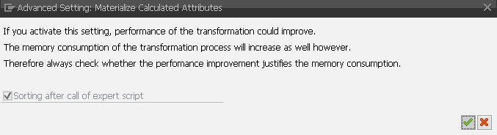
Figure 1.8 - Sorting after call of expert script

If the data is extracted by delta processing the sort order of the data could be important (depending on the type of the used delta process). By default, the flag is always set for all new transformations and it’s recommended to leave it unchanged. For older transformations, created with a release before 7.40 SP12, the flag is not set by default. So the customer can set the flag if they need the data in a specific sort order. Keep in mind that the flag has impact at two points
- The input/output structure of the SAP HANA Expert Script is enhanced / reduced by the field RECORD
- The result data from the SAP HANA Expert Script will be sorted by the new field RECORD, if the flag is set, after calling the SAP HANA Expert Script

The inTab and the outTab structure of a SAP HANA Expert Script will be enhanced by the field RECORD if the flag is set. The added field RECORD is a combination of the fields REQUESTSID, DATAPAKID and RECORD from the source object of the transformation, see Figure 1.9.
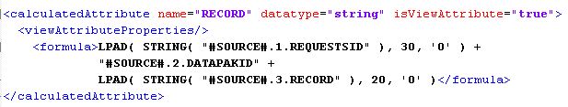
Figure 1.9 - Concatenated field RECORD

The RECORD field from the outTab structure is mapped to the internal field #SOURCE#.1.RECORD. Later on in a rownum node of the Calculation Scenario the result data will be sorted by the new internal field #SOURCE#.1.RECORD, see Figure 1.10.

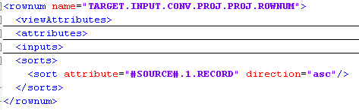
Figure 1.10 Calculation Scenario note rownum

1.2.2.2 The AMDP Class

The BW transformation framework generates an ABAP class with a method called PROCEDURE. The class implements the ABAP Managed DatabaseProcedure (AMDP) marker interface IF_AMDP_MARKER_HDB. The interface marks the ABAP class as an AMDP class. A method of an AMDPclass can be written as a database procedure. Therefore the BW transformation framework creates a HANA specific database procedure declaration for the method PROCEDURE, see Figure 1.11
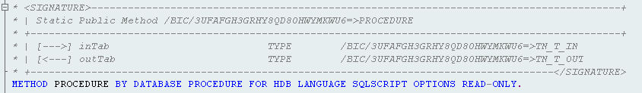
Figure 1.11 - Method PROCEDURE declaration

This declaration specifies the method to the HANA database (HDB), the language to SQLSCRIPT and further on defines that the database procedure is READ ONLY. The read only option means that the method / procedure must be side-effect free. Side-effect free means that only SQL elements (DML) could be used to read data. Elements like DELETE, UPDATE, INSERT used on persistent database objects are not allowed. These data modification statements can also not be encapsulated in a further procedure. You cannot directly read data from a database object managed by ABAP like a table, view or procedure inside an AMDP procedure, see (1) in Figure1.12.
A database object managed by ABAP has to be declared before they can used inside an AMDP procedure, see (2). For more information about the USING option see AMDP – Methods in the ABAP documentation.

Modification of the method declaration

In case of reading from further tables inside the SQL Script it could be necessary to change (enhance) the method declaration by adding the USING option. It is important to ensure that the first part of the method declaration is stable and will not be changed. Do not change the following part of the declaration

METHOD PROCEDURE BY DATABASE PROCEDURE FOR HDB LANGUAGESQLSCRIPT
OPTIONS READ-ONLY

The USING option must be added at the end of the declaration part, see Figure 1.12
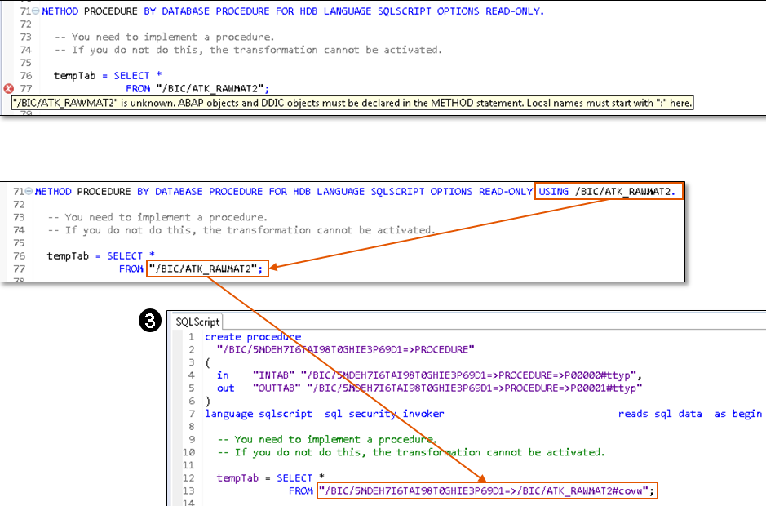Figure 1.12 - Declaration of DDIC objects

The AMDP framework generates wrapper objects for the declared database object managed by ABAP . The view /BIC/5MDEH7I6TAI98T0GHIE3P69D1=>/BIC/ATK_RAWMAT2#covw in (3) was generated for the declared table /BIC/ATK_RAWMAT2 in (2).

AMDP Class modification

Only the method implementation belongs to the BW transformation Metadata and only this part of the AMDP class would been stored, see table RSTRANSCRIPT. Currently the ABAP Development Tools for SAP NetWeaver (ADT) does not protect the source code which should not been modified, like in an ABAP routine. That means all modifications in the AMDP class outside the method implementation will not be transported to the next system and will be overwritten by the next activation process. The BW transformation framework regenerates the AMDP class during the activation process.
Later on I’ll provide some general recommendations which are based on experiences we collected in customer implementations and customer incidents. The general recommendation will cover the following topics
- Avoid pre’venting (prɪˈvent предотвращать) filter push down.
- Keep internal table small.
- Initial values
- Column type definition
- Avoid implicit casting
- Use of DISTINCT
- Potential pitfall (ˈpɪtfɔ:l ловушка) at UNION / UNION ALL
- Input Parameter inside underlying HANA objects
- Internal vs. external format…
- AMDP Class name
Until version BW 7.50 SP04 the AMDP class name is generated based on the field RSTRAN-TRANPROG. From BW 7.50 SP04 the field RSTRAN-EXPERT is used to generate the AMDP class name. The metadata storage for the AMDP routines was adjusted to align the AMDP metadata storage analogous to the ABAP metadata.

AMDP database procedure

Sometime, in BW 7.40, it could be happen that the corresponding database procedure is not generated. The report RSDBGEN_AMDP can be used to generate the database procedures for a given AMDP class.

1.2.3 Dataflow with more than one BW transformation

